ICDC On-Boarding Milestone 5
Infrastructure as Code

Cognizant Microsoft Business Group
20 North Wacker Drive #530
Chicago, IL 60606

Notice of Confidentiality ©2021 Cognizant Microsoft Business Group All rights reserved.

IS SUBJECT TO THE TERMS OF THE COGNIZANT MICROSOFT BUSINESS GROUP NON-DISCLOSURE AGREEMENT. NEITHER THIS DOCUMENT NOR ITS CONTENTS MAY BE REVEALED OR DISCLOSED TO UNAUTHORIZED PERSONS OR SENT OUTSIDE THE AFOREMENTIONED COMPANY WITHOUT PRIOR PERMISSION FROM COGNIZANT MICROSOFT BUSINESS GROUP

Setting up remote state
- Create a resource group
- Create a storage account v2
- Create a blob container named “tfstate”

Additional resources created should match deployment plan naming standards

Example:
If client Sheboygan’s resource group is named AZ-UW1-SHRDSVC-ADMIN-RG, the resource group of the tfstate storage account is AZ-UW1-SHRDSVC-TFSTATE-RG.
If client Sheboygan’s storage account name is azuw1sheboygansa001, the storage account of the tfstate will be azuw1tfstatesa01.
*resources require globally unique name. For demo purposes, add numbers at the end of the name*

https://dev.azure.com/10M-SOLUTIONS/Solutions-Infrastructure/_git/CAF-ALZ-TERRAFORM?path=%2Fdeployment
(location of our template terraform code)

Getting started with deployment
- Clone the template repo down to your machine
  - To clone a repo, open the DevOps project. Open the Repos tab and click clone on the top right corner to clone a repo to visual studios code.
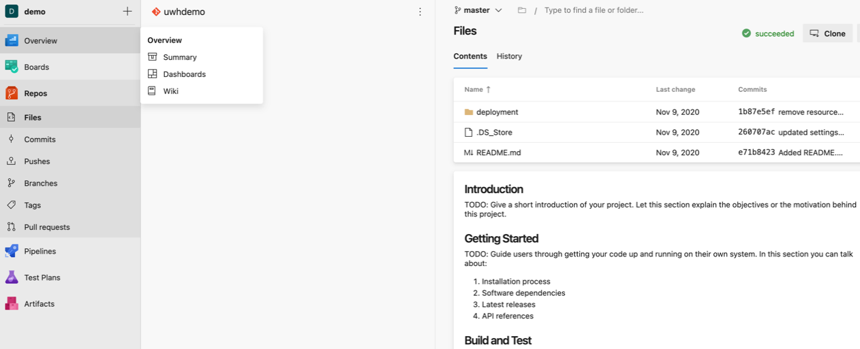

- Create a new repo in your own DevOps project, and clone that repo down to your local machine as well and give it a name
  - At this point you should have 2 new folders on your local machine, 1 for each repo
Example:
C:\Users\username\Desktop\Repositories\Azure\CAF-ALZ-TERRAFORM (template repo)
C:\Users\username\Desktop\Repositories\Azure\PNA_Test (new repo)
- In File Explorer, copy the deployment folder within the template repo folder to your empty new repo folder

- In your new repo on your local machine, navigate to the following folders: deployment\hub\environments and deployment\spoke\environments
  - Update environment subfolder name at this location to match the intended Terraform workspace name. For example, if you are deploying a HUB to East US, you might want to name the Terraform workspace HUB-EASTUS. The environment folder must match this name.
    - Ex: Update the following
deployment\hub\environments\PROD-HUB to
deployment\hub\environments\HUB-EASTUS

Note: Sometimes you might need more hubs\spokes than what is in the template code. You will need to create\remove subfolders under the deployment\hub\environments and deployment\spoke\environments

- Copy and paste one of the existing environment folders to a new folder within the environments folder.
  - Rename the folder accordingly
  - Repeat for each new HUB\SPOKE that you need
- In VS Code, open the pipeline.yaml files in each of the environment subfolders.
- Update variables section to the correct workspace name, service connection and storage account.
  - Example for the HUB
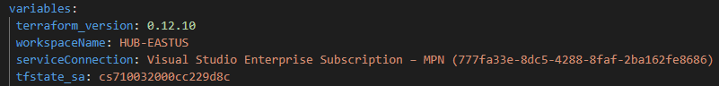

  - Example for SPOKE
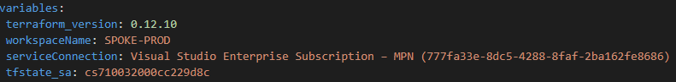

The service connection name can be found in a clients Azure DevOps under Project Settings>Service connections
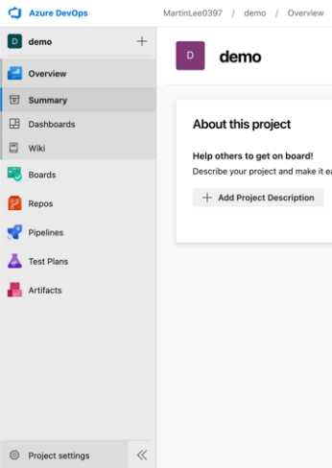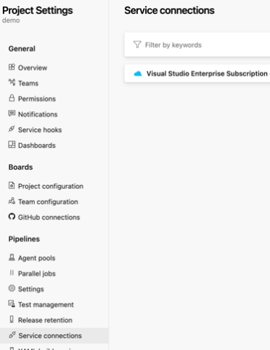
Creating new environments
Update the settings based on the deployment plan (naming, IP address schema, etc)
Each resource is referenced in two places
- Environment/HUB-EASTUS/settings.yaml
- Terraform/Resource.tf

To adjust the terraform code, you will visit both files to verify the data and update the date if necessary, to match the deployment plan.

Deployment plan

Corenetworking.tf
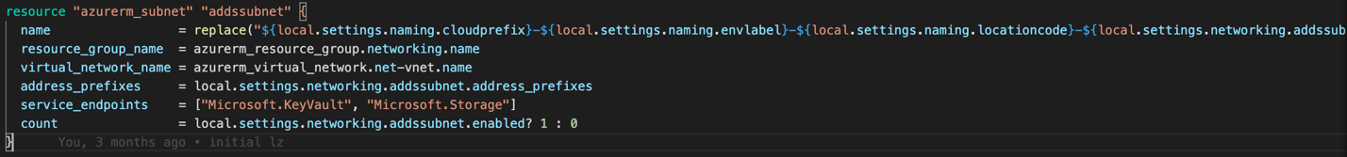

Settings.yaml
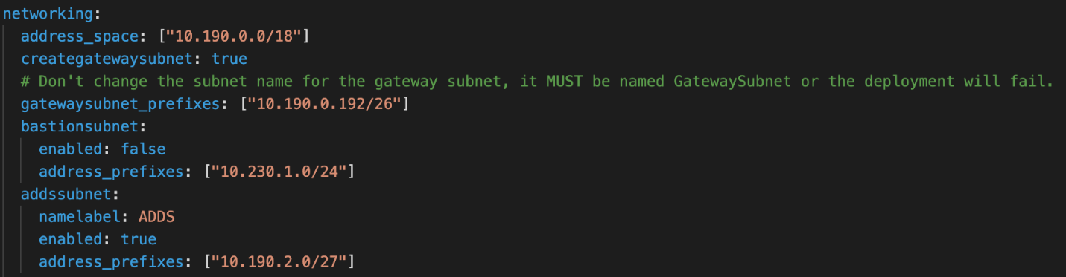

For each resource, verify the resource name with the settings.yaml file and resource.tf file.
In this example, when updating the virtual network, the resource name is AZ-UW1-SHRDSVC_10.62.0.0/16.

If we look at the code, we can break down how our resource name is pulled.

name = replace("${local.settings.naming.cloudprefix}-${local.settings.naming.envlabel}-${local.settings.naming.locationcode}-${local.settings.naming.resourcelabels.vnet}-001_${local.settings.networking.address_space[0]}", "/", "_")

For Example:
For this resource it is stating, within the local environment, look at the settings file. Within the settings file, look for the naming section and input the value of cloud prefix.
Within this resource, the name value will be replaced with the following values.

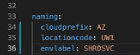

For each resource, verify the resource name with the settings.yaml file and resource.tf file.
In this example, when updating the virtual network, the resource name is AZ-UW1-SHRDSVC_10.62.0.0/16.

Below are different resources within the deployment plan and the applicable files that reference each resource.

Resource group: settings.yaml, Main.tf
VNet: settings.yaml, CoreNetworking.tf
Subnet: settings.yaml, CoreNetworking.tf
Storage account: settings.yaml, storage.tf
Azure Bastion: settings.yaml, bastion.tf
Virtual Machine: settings.yaml, DomainController.tf
Availability set: settings.yaml, DomainController.tf
App Security Group: settings.yaml, AppSecurityGroups.tf
Network Security Group: settings,yaml, NetworkingSecurityGroups.tf
Log Analytics: settings.yaml, LogAnalytics.tf
Key Vault: settings.yaml, Keyvault.tf
Revovery Services vault (RSV): settings.yaml, RSV.tf
Automation Account: settings.yaml, Automation.tf
Create an Azure DevOps pipeline
- Browse to the DevOps org and project
- Click pipelines on the left menu, then new pipeline in the top right
- Click Azure Repos Git as your code location
- Click the repo
- Click Existing Azure Pipelines YAML file
- Type in the path to the file and click continue

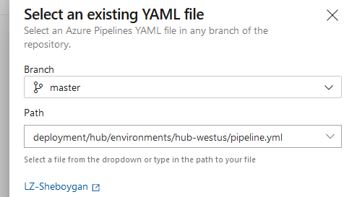

- Setup the variables by clicking the variables button on the top right. The variables that need to be added and passed into the pipeline are listed in the comments at the head of the pipeline YAML file. The workspace name is the Terraform workspace, which should match the environment folder.
- Click the arrow next to the run button and save the pipeline, but don’t run it yet
- Go back to pipelines, then click the all tab
- On the far right of the pipeline name click the 3 dots button, then rename the pipeline to a descriptive name.

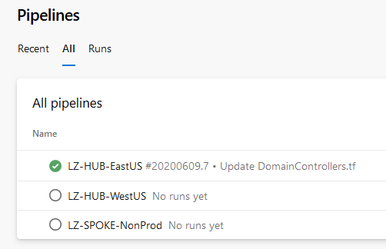

- Review the pipeline and settings, then you can run the pipeline

